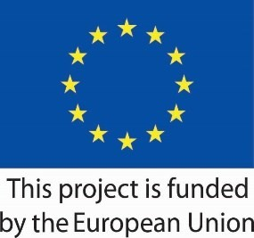

Research on local job market skills and opportunities to support the economic empowerment of survivors of trafficking and domestic violence in Tirana, Kukës, Dibra and Saranda
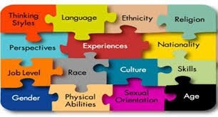

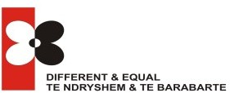

Tirana, November 2018

Experts:

Manuela MURTHI

Sonila SULAJ
Zef GJETA

This study report was developed by the “Different & Equal” organization in the framework of the project "Cooperation between CSOs and groups of former victims of trafficking and domestic violence for the economic empowerment of victims", funded by the European Union and implemented by the "Family and Childcare Centre" (KMOP) and "Different & Equal" (D&E).

Different &Equal is a nonprofit organization dedicated in providing high quality reintegration services for victims of trafficking, exploitation and abuse, and to improving the legal, institutional and social context to prevent and counter these violations of human rights.

Family and Childcare Center (KMOP) is one of the oldest Greek non- profit organization, in supporting disadvantaged groups. KMOP is committed to kindling a better world and has a sound track record in the management of national and international projects, as well as experience with sub-granting schemes in the Balkan region.

This report was produced with the financial support of the European Union. The content of this report does not necessarily reflect the official opinion of the European Union, is only responsibility of the Center for Social Action and Innovation Centre (KMOP) and the organization "Different & Equal" (D&E).

LIST OF ABBREVIATIONS
Chapter: 1. SETTING THE SCENE (DESK RESEARCH FINDINGS)
.................................................................................8

CSO | Civil Society Organization
DCM | Decree of Council of Ministers
D&E | Different & Equal
DHS | Demographic Health Survey
DVoDV | Victims of Domestic Violence
GDP | Gross Domestic Product
IMF | International Monetary Fund
IOM | International Organization for Migration
LFS | Labour Force Survey
ICT | Information Communication Technology
MFC | Multi-Functional Centre
MoHSW | Ministry of Health and Social Welfare
MAP | Medicinal and Aromatic Plants
NES | National Employment Service
NESS | National Employment and Skills Strategy
NGO | Non-Governmental Organization
SME | Small Medium Enterprise
VET | Vocational Education Training
VoT/PVoT | Victim of Trafficking/Potential Victim of Trafficking

TABLE OF CONTENTS
Chapter: 1. SETTING THE SCENE (DESK RESEARCH FINDINGS)
.................................................................................8
ABSTRACT 5
INTRODUCTION 6
- SETTING THE SCENE (DESK RESEARCH FINDINGS) 8
  - Overview and evaluation of the labour market needs and opportunities 12
  - Overview of the per capital income 10
  - Unemployment rates in the four -targeted areas 12
  - Existing economic activities in the four-targeted areas (examining possibilities through institutes,
consultant companies, various associations, lawyers’ associations etc.) 13
  - Development of social economy in the four- targeted areas 20
  - Overview of the existing vocational and training employment programmes addressing the needs of potential victims of trafficking in the four-targeted areas in Albania 20
  - Overview and evaluation of the specific characteristics of the former victims of trafficking and of the challenges and obstacles that might hinder them to access the labour market 20
  - Overview and evaluation of the market needs that former victims meet now 22
  - Overview and evaluation of the training needs to address future additional labour market needs 23
- METHODOLOGY (FIELD RESEARCH) 24
  - Sampling procedures and participant recruitment for focus groups and interviews 24
  - Social and demographic characteristics of the respondents in focus groups and interviews 25
- RESULTS (FIELD RESEARCH) 26
  - Findings of the focus groups 26
  - Findings of the interviews with victims of trafficking 28
  - Findings of the interviews with the other actors involved 29
  - Common and different aspects between the interviewees 31
  - Gaps, challenges and good practices identified through the focus group and the interviews 31
- CRITICAL ANALYSIS OF FINDINGS 32
- CONCLUSION AND RECOMMENDATIONS 33
References 35
Annexes 37

ABSTRACT
Chapter: ABSTRACT

The objective of this study was to assess and identify the needs in skills and opportunities in the labor market in the four project areas, namely Tirana, Kukës, Dibra, and Saranda. This in turn, will inform the development of vocational training priorities and programs for former victims and will help them tap into their business potential.
Utilizing a participatory and forward-looking approach the evaluation involved three types of techniques for data collection: quantitative, qualitative and observation. A lliterature review, focus groups, structural face to face interview, key informant interviews and observation were specific techniques used. This methodology offered the possibility of a triangulated analysis and conclusion. The centrepiece of the qualitative data collection was a poll of relevant stakeholders per target area - in total (4) focus groups with at least (8) participants.
Analysis of the research data revealed that the labour market is a relatively limited market; however, there are VoT/PVoT/VoDV employment opportunities in different sectors suitable for this category.
Existing vocational training programs addressing the needs of potential VoT/PVoT/VoDV in four-zone areas are in place. The problem lies in the fact that market and information segmentation prevent chain linking to ensure a proper marketing communication system. Self-employment for VoT/PVoT/VoDV, such as doing handicrafts seems to be an opportunity, but there are a lot of difficulties at start-up phase, including training and investments.
Challenges for businesses at the central and local level are present in reaching the project target group (VoT/PVoT, VoDV). They had no information on how to access the target group or what channels of communication to use in order to increase their opportunities for being exposed to the employment possibilities.
CSO connectivity with businesses is another area of concern. Communication with organizations which deal with the target community (VoT/PVoT,VoDV) remain welcome in the future so they can contribute in fulfilling these unmet needs.

INTRODUCTION
Chapter: INTRODUCTION

Rationale for the project
Addressing and informing the development of the vocational training priorities in compliance with the labour market trends, especially those affecting the former victims, is crucial in directing beneficiaries to appropriate training opportunities and suitable employment.
The successful reintegration of victims of trafficking depends on a wide range of factors and situations, including the environment into which she is to reintegrate, the different support mechanisms for re- integration, the role of the state, civil society and local communities¹.
Some criteria for determining whether an individual can successfully reintegrate socially and economically are professional/employment opportunities, education and training opportunities, healthy social environment (including anti-discrimination and anti-marginalization), and access to services and opportunities².
This project intends to identify the needs in skills and opportunities in the labour market, which, in turn, will inform the development of vocational training priorities and programmes for former victims and will help them tap their business potential. Local market analysis can improve decisions about which vocational training to offer and how to design appropriate programmes in project area.

General objective of the project
The project “Cooperation between CSOs and groups of former victims of trafficking and domestic violence for the economic empowerment of victims” aims to address CSOs and informal community groups in Tirana, Kukes, Dibra and Saranda (especially remote areas) where many former victims of trafficking or domestic violence live.
This project will contribute to identifying their needs to grow/ formalize as CSOs and specialize in the reintegration of former victims of trafficking and/or domestic violence and will build their capacities through training (and on the job support mentoring/coaching) tailored to their needs.

Specific objectives
  - To assess the capacity and facilitate the development of CSOs as organizations but also as support providers for former victims through training, best practice exchanges and publication of reports that will advocate for rights.
  - To support the economic empowerment of former victims through a small grant scheme that will finance a number of new and effective economic empowerment initiatives and to support continued mentoring that will ensure economic empowerment, independence and continuity of funding.
  - To create a referral and self –support network through the implementation of a peer support program that will train former victims to become per mentors.

¹ Surtees, R., Monitoring anti-trafficking re/integration programs. A manual 2010, NEXUS Institute, Washington
² Policy Issues and options for Women’s Economic Empowerment” A Policy Issues Paper, UNWOMEN 2012

The general structure of the research
Chapter: INTRODUCTION

The research is presented in sections, starting first with “Introduction” and closing out with the “Conclusion and Recommendation”. The logic of the research follows the below logical section:
Session 1 INTRODUCTION
Describes the process leading to the selection of the methodology that project applied for describing the local market skills, needs, and opportunities in the four targeted areas (Tirana, Kukës, Dibra, Saranda districts).

Session 2 DESK REVIEW
Desk review includes the analysis of relevant and available data and resources (reports, policy documents, reports from previous surveys, research etc.) in relation to the labour market needs, in particular those affecting the project’s target group. This section includes review of any reports, research and available data on characteristics and needs of the local job markets. It also includes relevant measures, initiatives and/or programmes that have already been implemented—or are being implemented.
The evidence provided in this section is based on secondary data to understand the labour market trends, especially those affecting the project’s target group, and to identify the key characteristics and opportunities of the local job market in the (4) areas where the project will be implemented, namely Tirana, Kukës, Dibra, and Saranda. As specified this section is detailed according to various sub-sections exploring the key interest themes.

Session 3: METHODOLOGY of FIELD RESEACRH
This section presents the methodology used for field row data. The research report is based on quantitative and qualitative surveys conducted. The field research gathers primary information from two main sources:
- Focus groups with representatives from different sectors in the four (4) target areas that provide input in the labour market needs analysis
- Individual, face-to-face, or telephone interviews with local business/employers, chambers of commerce, vocational training providers, employment agency, CSOs and other local stakeholders per target area.
The row data gathered from this field work highlights problems related to access of VoT/PVoT/VoDV. The data is compiled in the aim of to addressing and informing the development of the vocational training priorities and programmes for former victims as well as identify business opportunities.

Session 4: RESULTS (Field Research)
The results section presents the findings from the research work derived from focus group findings. The section brings out findings from the interviews with victims of trafficking as well as findings from the interviews with the other actors involved.
Common and different aspects between the interviewees are described including gaps, challenges and best practices identified through the focus groups and the interviews.

Session 5: CRITICAL ANALYSIS of FINDINGS
Chapter: SETTING THE SCENE (DESK RESEARCH FINDINGS)
This section reflects critically on the findings of the field research linking them to the desk research findings and the aims and objectives of the project.

Session 6: CONCLUSION and RECOMMENDATION
Following the chronological order of the above analysis sections the conclusion and recommendation section presents the conclusions of the field and desk research combined and offer national recommendations for policy and implementation based on the critical analysis. This section also includes the specific recommendation for the topics under analysis for each project region.

SETTING THE SCENE (DESK RESEARCH FINDINGS)
Albania is a country that has significantly grown economically in the last couple of decades in comparison to other developing countries in the world. It is also on the list of becoming a member of the European Union and this has led the government to implement important actions toward reaching social goals such as working on gender equality and children’s rights. However, despite the government’s efforts, Albania continues to have low social indicators, in particular due to the disparity of growth between the more developed regions that tend to be the centre and south of the country and the rural and northern area. There substantial inequalities amongst rural and urban contexts and high levels of exclusion of vulnerable populations such as women, children, people with disabilities, Roma and Egyptian communities³. This suggests that Albania has not experienced what economists call a “pro-poor growth” of the country. This means that Albania has an accelerated economic growth of the middle and higher socio-economic class and a stagnant growth situation for the poorest cohorts.
According to the last census⁴, Albania has a total population of 2.800.138 people, of which 1.397.079 are women, 1.403.059 are men and 163.493 are children under the age of 4. Of the total Albanian population, 25.4% are poor and 4.7% are extremely poor⁵. The poorest region is in the Mountain Region (44.5% poor and 10.8% extremely poor), followed by the Central, Coastal and Tirana regions, respectively. This distribution unfortunately coincides with the insufficient provision of social services and employment opportunities; given that these are concentrated in the urban areas. This reality affects all the Albanian population, but especially the most vulnerable groups amongst which women and children are included.
Despite the lack of official and valid demographic data on this population, it is a specific ethnic group that seems to be largely excluded from services and employment opportunities and larger efforts should be done to improve their quality of life.
The 2011 National Census states that there are 137.435 people with disabilities, from which 75.239 are women and 62.196 are men. To date the census presents only data for people 15+. The census also divides the resident population with disabilities⁶ into the following types: seeing (49.996), hearing (37.919), mobility (81.585), cognition (40.586), self-care (39.402) and communication (33.084). This means that approximately 5% of Albanian population reported some type of disability that indicates the need for inclusion policies and programming in order to uphold the rights of this group. In particular, actions need to be focused on those families with young children.

³ National Report Status of Women and Gender Equality in Albania 2011- UN Women & United Nations Albania
⁴ INSTAT- Census 2011
⁵ Living Standard Measurement Survey, LSMS 2002, 2005, 2008
⁶ There can be cases when people report more than one disability, which is the reason why the number appears to be larger than the total number of people with disabilities.

The registered unemployment rate for 2011 was 13.3%, of which women represent 14.3% and men represent 12.4%. The largest unemployment rate rests in the age group that falls between 15-29 years. It is estimated that there is at least 50% of employment in the informal economy.
Chapter: SETTING THE SCENE (DESK RESEARCH FINDINGS)
Being lower in the rural areas and for vulnerable communities, these indicators are consistent with the rest of the social indicators of the country.
Violence against children and women, women’s participation in the black market, exclusion of people with disabilities and of Roma communities are social problems that are still rooted in Albanian society⁷. Important actions for social mobilization, policy and programming need to be undertaken in the short and medium term to address these issues. Investment in these strategic areas not only has to increase substantially, but also to be better targeted.
The Government of Albania has developed a set of policy strategies in order to address all these social issues and improve the quality of life of its citizens. The more relevant strategies for this study are: The Social Inclusion Cross- Cutting Strategy (SICS) 2007 – 2013⁸, the Social Protection Sector Strategy (2007- 2013)⁹, The National Action Plan for Roma (2010-2015), the National Strategy on People with Disabilities (2006)¹⁰, the National Strategy for Gender Equality, Gender-Based Violence and Domestic Violence 2011- 2015 and the Action Plan for Children (2012-2015).

Overview and evaluation of the labour market needs and opportunities
The process of socio-economic reintegration of women and girls largely depends on the general social, economic and political conditions in the country. Specific to economic reintegration, a snapshot of the employment and labour market from the 2015 firm registry shows that the median size of firms in Albania is 1 employee. Micro firms (1–4 employees) represent 90 % of the total number of registered firms and account for 29% of jobs. Taken together, firms with less than 10 employees account for 38% of all employment.¹¹
Employment in the formal private sector is concentrated in Tirana region, which accounts for more than one-half (52 percent) of all jobs (Graph 1). The employment distribution by region overall reflects the geographical disparities in the distribution of firms. According to the LFS (which should cover both formal and informal employment), 28 percent of all employment (formal and informal) is based in Tirana. However, Tirana, which hosts 35 percent of all registered firms, accounts for more than one-half of total formal sector employment and larger firms are also concentrated there.

⁷ Interview with Terre Des Hommes- Tirana November 2012
⁸ National Report Status of Women and Gender Equality in Albania 2011- UNWomen & United Nations Albania. 2001. The ultimate objective is to lay the ground for the formulation of a social inclusion action plan, a standard requirement for EU accession - http://www.aidharmonisation.org.al/?fq=mesi&pos=1&mt=shfaqart&aid=218
⁹ Ibidem. “The Social Protection Sector Strategy (2007-201341) covers all the social protection policies of MoLSAEO. (…)” http://www.aidharmonisation.org.al/?fq=mesi&pos=1&mt=shfaqart&aid=191
¹⁰ Government of Albania, Ministry of Labor, Social Affairs and Equal Opportunities- OECD. National Strategy on People with Disabilities. 2006
¹¹ Job dynamic in Albania (2018)

Graph 2.1 Percentage of job distribution according to regions
Chapter: SETTING THE SCENE (DESK RESEARCH FINDINGS)
52
12
7
5
5
5
4
3
3
2
The same source evidences that one out of four jobs are in the low-productivity trade and repair sector, while another 25 percent are in the industry sector (excluding construction and agro-processing). Remaining jobs are mostly in business services (14 percent of jobs), tourism (12 percent), and other services (11 percent) (Graph 2).

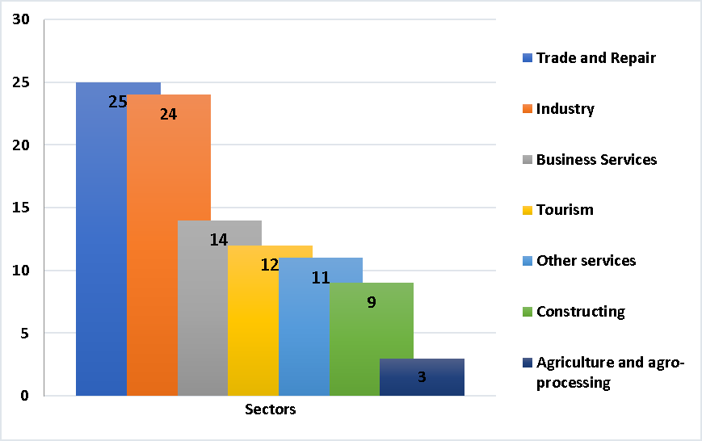
Graph 2.2 Percentage of job distribution by economic sector (2015)
Seventy-five percent of net employment is created in large firms, while small firms contributed negatively to job creation instead. Firms with less than 10 employees accounted on average for only about 8 percent of jobs created but for 20 percent of jobs destroyed during the same period (2013–2015).
The majority of new entrant firms are counted to be in the tourism sectors, but also most firms that exit are a part of this sector also. This study reveals that one-third of exit firms operate in trade and repair and 18 percent operate in tourism. Tirana, Durrës, and Vlorë are more dynamic, accounting for the highest shares of new entrant firms (38 percent, 15 percent, and 9 percent, respectively) but also of exit firms (32 percent, 12 percent, and 8 percent, respectively).

Overview of the per capita income
The reintegration of women and girls returning from a trafficking experience is deeply affected by regional inequalities, with the central region having the highest level of GDP per capita and the north region the lowest.
More recently, economic growth in Albania has been positive. After near stagnant growth, per capita income growth reached nearly 3 percent in 2015 and 2016, due to higher domestic demand, private investment, and the recovery of EU trading partners (IMF 2017). The highest level of GDP per capita at prefecture level was in Tirana at 41% above the national average. The second most prosperous prefecture was Fier (13 % above average), followed by Durrës (4.5% above average). According to INSTAT, in the South

Region, GDP per capita (2015) was around 8.5% below the national average. The GDP per capita of all the other prefectures was below the national average. The lowest was in Dibra (33% below average), followed by Kukës (30.5% below average) and Korça (30% below average).
Chapter: SETTING THE SCENE (DESK RESEARCH FINDINGS)
Services currently comprise the largest sector of the economy (45 percent of GDP), and over the last few years provided the highest contribution to economic growth with higher-than-average growth rates (over 4 percent). The contribution of agriculture (which comprises nearly 30 percent of GDP) to economic growth has shrunk over time; since 2014, manufacturing and other industries have increased their contribution to growth (Graph 3).

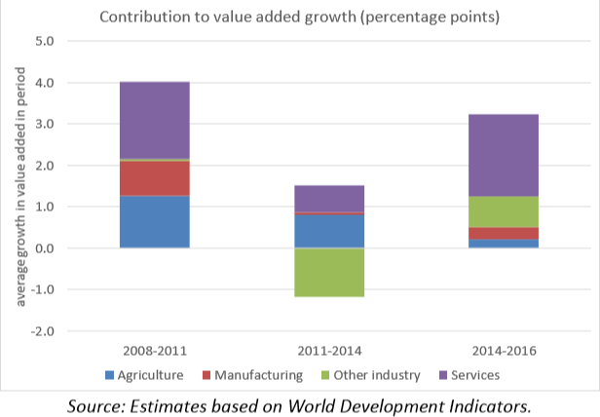
Graph 2.3 Contribution to value added growth (in %)

In regard to the project selected regions, according to National Regional Statistics 2018 it is evidenced that:
12

Kukes | Occupies 1.7% in the GDP structure at Albania for 2016, making a contribution in real terms against 2015 by minus 0.04% while GDP per capita was lower than it averages at the country level of 314 thousand ALL. Number of enterprises in this region amounted to 1,946 and constitutes only 1.2% of all enterprises in country rank, the lowest number in Albania.
Dibra | Occupies 3.3% of the GDP structure in Albania in 2016, contributing in real terms to 2015 by 0.20%, while the GDP per capita was lower than the average of the country at 382 thousand ALL. Number of enterprises in this region amounted to 2.906 and made up 1.8% of all enterprises at country level. Only the region of Kukës counts fewer enterprises than Dibra.
Tirana | Occupied 40.4% in the GDP structure in Albania for 2016, making a contribution  in real terms against 2015 of 1.62%, meanwhile GDP per capita was higher than the countrywide average of 699 thousand ALL. Tirana marks the highest number of enterprises with 54.291 units making up 33.4% of all total enterprises at country level.

¹² http://www.instat.gov.al/media/4149/regjistri-i-ndermarrjeve-2017.pdf

Vlora where Saranda belong | Reached 5.9% in the GDP structure in Albania for 2016, contributing in real terms to 2015 by 0.44%, while GDP per capita was higher than the average in the country level of 462 thousand ALL. The number of enterprises in this region amounted to 11,946 and accounts for 7.4% of all enterprises in the country.
Chapter: SETTING THE SCENE (DESK RESEARCH FINDINGS)
As a typical area of the north, the graph below presents the analysis of Gross Domestic Product (GDP) contribution according to the sector (graph 4). As it is shown, the economy of this area is based on the agriculture sector.

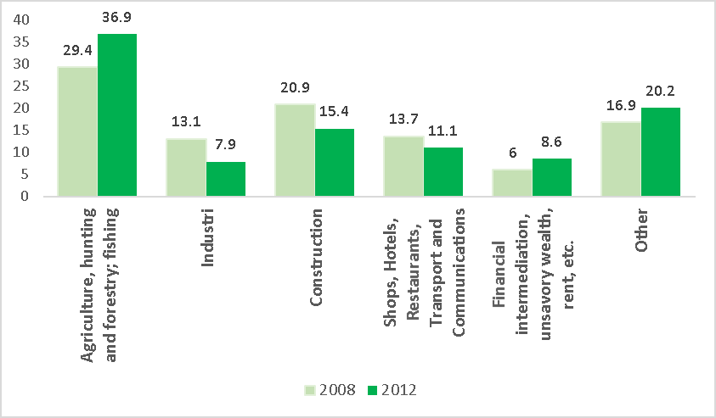
Graph 2.4 Kukes Prefecture: Gross Value Added by sectors (2008-2012 in %)
Likewise, the GDP per capita level is lower, being about 30% lower than the national average and 12% lower than the average of the northern area.¹³

Unemployment rates in the four -targeted areas
Employment is perhaps the most important factor in the process of women’s reintegration. Over the past few years, under the National Employment and Skills Strategy (NESS), the National Employment Service (NES) has made important steps of transformation and now operates under a new service model in at least six reconstructed offices that include counselling services and mediation to better match the unemployed with the correct employers (Republic of Albania, 2017). Critical investments were made in the operability of its information and communications technology (ICT) system and links with other national databases to support job matching (Republic of Albania, 2017).
An analysis by regions indicate that in 2017¹⁴, prefectures with the highest employment rate are: Elbasan (61.2 %), Dibra (55.5 %) and Fier (54.7 %), whereas those with lowest employment rate are Durrës (45.7 %) and Vlorë (44.9 %). Prefectures with highest unemployment rate are prefectures of Vlora (23.9 %) and Tirana (16.7 %) whereas the lowest unemployment rate is noted for the prefecture of Dibra (7.4 %).

¹³ Analiza e Zhvillimit Ekonomik dhe Shërbimeve Publike, Europartners Development, 2015
14 INSTAT, Albania Labor Force Survey 2017

In the prefecture of Tirana in 2017, services employ the major part of the total employed, specifically 68.4%. In this prefecture 25.4% of the total employed is in industry while only 6.2 % of them are engaged in agriculture activities. In Vlora (Saranda included) prefectures, about 45% of the employed are in services, with 27.1 % in industry and 27.7 % in agriculture respectively. In Dibër and Kukës prefecture, it is employment in agriculture that prevails comprising more than 40% of the total employment.
Chapter: SETTING THE SCENE (DESK RESEARCH FINDINGS)

Table 2.1 Employment and Unemployment female rate by Prefectures and years¹⁵

 | Employment female rate |  | Unemployment female rate
Qarks
 | 2016 | 2017 | 2016 | 2017
Dibër | 52.6 | 52.1 | 3.4 | 5.2
Kukës | 40.5 | 43.2 | 20.2 | 13.2
Tiranë | 37.0 | 38.4 | 18.5 | 16.4
Vlorë (includes Saranda) | 35.3 | 35.6 | 32 | 27.4

Besides the employment rate, the gender pay gap needs attention. The gender pay gap is 10.5%. Men have a gross monthly average wage of 10.5% higher than women. It results to stand higher among employees who are employed in economic enterprises belonging to the economic activity group “Mining and quarrying; manufacturing; electricity, gas, steam and air conditioning supply; water supply; sewerage, waste management and remediation activities”. For this group-activity, the gender pay gap is 35.3%. Compared with the previous year, the gender pay gap for this group of activities has decreased by 2.5 percentage points.
Over the year 2017, youth aged 15-29 years old that were neither employed nor receiving education or training account for 29.7% of all youth population. This figure stands in compliance with the context that the trafficked young women belong to. Youth who are neither employed nor receiving education or vocational training differ by sex and status in the labor market. It is noted that males are more active than females. 49.7% of males are seeking a job and are available to work, while only 22.4% of females are seeking a job and are available to work.
In 2017, the most paid professions are: lawmakers, senior civil servants and executive directors; specialists with higher education (professionals); and technicians and specialists in implementation. Professions below the average level are: qualified employees of forestry and fishing agriculture; workers of professional professions; and craftsmen, artisans and related professions.

Existing economic activities in the four-targeted areas (examining possibilities through institutes, consultant companies, various associations, lawyers’ associations etc.)
Albanian economy is dominated by micro and medium size enterprises and is a net exporter. Disparities between urban and rural areas are still in place. Agriculture is the predominant activity in rural areas, however there are few agricultural local units compared to the other economic activities¹⁶.
An estimation through the “Estimation of sectorial Job Multipliers in Albanian Economy” carried out from the “RISI Project” in Albania during 2018 presents the figure below displaying companies that are active in different sectors of the economy and the respective number of persons they employ. From the statistics shown in the figure below it can be understood the size of companies varies between different sectors.

¹⁵ ibid
16 Albanian Employment and Skills Strategy 2014-2020

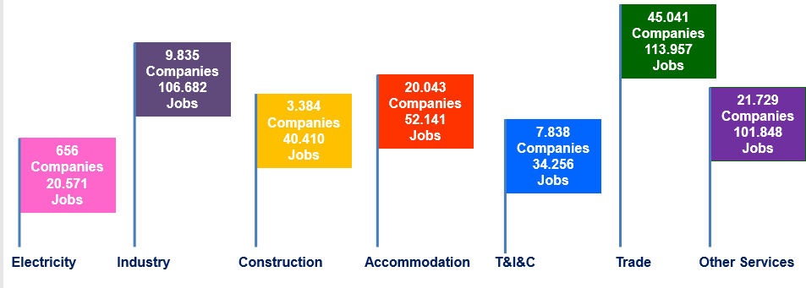
Figure 2.1 Numbers of companies and number of employees according to the sectors (2017)
Chapter: SETTING THE SCENE (DESK RESEARCH FINDINGS)
Considering that the region is composed of different municipalities, the most developed region is the center region (i.e Diber municipality in Diber region), where 41.5% of total enterprises operate. The situation is the same for new registrations during 2017 with 46.2 %. The contribution in employment is 54.4
%. Trade economic activity represents 32.8 % of active enterprises in the center region. This phenomenon is similar in all prefectures as well as all municipalities. We can also overview it with specific focus on the four project selected areas:

Table 2.2 Active enterprises by economic activity, end of the year 2017

Qark | Producers of goods | Agriculture, forestry, fishing | Industry | Construction | Producers of services | Trade | Transport and storage | Accommodation and food service activities | Information and communication | Other Services
Diber | 901 | 531 | 296 | 74 | 2005 | 989 | 129 | 446 | 26 | 415
Kukes | 799 | 629 | 127 | 43 | 1147 | 481 | 78 | 269 | 17 | 302
Tirane | 7375 | 1388 | 3799 | 2188 | 46916 | 18630 | 1910 | 7799 | 1988 | 16589
Vlore | 3406 | 2156 | 805 | 445 | 8504 | 3806 | 521 | 2417 | 114 | 1682

Based on the figures above, the Diber and Kukes regions’ economic development shows a gradual development of services with a focus on agriculture and livestock. Kukes is a well-known place with a tradition in the breeding of sheep. The quality of the meat and wool of the lamb sheep are known throughout the Balkans. Although it is a region rich in numerous natural resources and numerous opportunities, the entire Kukes Region is one of the poorest areas in Albania.
The table below (Table 2.3) presents a picture of project selected municipalities in regard to the active enterprises according to their size. Municipality of Tirana territory numerates the biggest number of enterprises. It is obviously demonstrated by the chart that the number of enterprises employing 1-4 people dominate the local economies of Diber, Kukes, Tirane, and Sarande.

Table 2.3 Active enterprises by territorial division and size of enterprise
Chapter: SETTING THE SCENE (DESK RESEARCH FINDINGS)
Grouped by number of employed – end of 2017
Municipality
Total | 1 - 4 | 5 - 9 | 10 - 49 | 50+
1301 | 1192 (91.6%) | 41 | 58 | 10
1069 | 944 (88.3%) | 55 | 56 | 14
46948 | 39444 (84.1%) | 3848 | 2749 | 907
2356 | 2120 (89.9%) | 143 | 79 | 14

Diber Kukes Tirane Sarande

As can be observed from the table 2.3, the economy is dominated by individual or family businesses and is mainly based on small businesses. The structure of enterprises is also demonstrated with 85% of the local economy being made up of small businesses employing up to 4 people, mostly households for all the region under study.
In the north regions – Kukes and Diber --large business companies are concentrated mainly in the service sector (48%) and in trade (34%) while construction (16%) and manufacturing (13%) of energy mines occupy a smaller percentage. This indicates once again that the economy of the area is based on the sectors that generate less income. Foreign-owned enterprises are almost insignificant with only 2 enterprises comprising 1.1% of large business enterprises. Those with common capital account for only 1.6% of the total enterprises of this category.
Although some regions seem to be somewhat underdeveloped, opportunities, geographical positioning at a favourable point on the border with Montenegro, Kosovo and Macedonia, fast access to neighbouring Kosovo border markets (Prizren, Gjakova, Dragash), or Montenegro, (Berane, etc.) makes Kukes and Diber centres of cooperation, institutions, and exchanges. For Kukes, the development of the highway Durrës - Morine has increased the importance of this region, in part, due to the direct link with Kosovo and markets from other neighbouring countries. Saranda’s geographical position allows it to also be a favourable point on the border with Greece which promotes local production as well as the tourism development. For Diber, the expected “Rruga e Arbrit” will also be an opportunity for strengthening and boosting the exchange opportunities.
In Albania, women as owners/administrators make up 29.7% of the total active enterprises in 2017 compared to 26.8% in 2016. The concentration of women as owners or administrators is higher in trade activity with 9.2%. The highest percentage of enterprises managed by women is in prefecture in Tirana with 35.6%. Enterprises led by women are mainly micro enterprises with 1-4 people employed and make up 91.6% of this group. However, figures from INSTAT entrepreneur registry evidence that 24.2% of big enterprises with 50 or more employed are managed or owned by women compared to the 19.2% in 2016. Diber and Kukes demonstrate percentages of 22.9% and 22% respectively.

Table 2.4 Main characteristics of enterprises, end of the year 2017

Municipality | Active | Registered during 2017 | Women Ownership | Women Ownership  (%)
Diber | 1301 | 168 | 298 | 22.9
Kukes | 1069 | 228 | 236 | 22
Tirane | 46948 | 8922 | 17162 | 36.5
Sarande | 2356 | 381 | 849 | 36

Considering that agriculture and livestock activities are shown to as an important activity of mountain and rural areas as a form of domestic production, the table below (table 2.5) shows the number and rate of the farmers in the total number of activities in the selected municipalities. It should be noted that these activities (domestic) may also be an opportunity of females living on the countryside of their urban areas. Farmers which sell their products are registered to tax offices and provide a unique Identification Number to Persons of Taxation (NIPT). Registration processes make it possible for farmers to have legal personality and to be part of a statistical business register. The number of farmers at the end of year 2017 is 313 for Diber, 291 for Kukes, 188 for Tirana and 106 for Saranda. Kukes and Diber have considerable rates of farmers as part of total enterprises, respectively 27.2% and 24%. While Tirana and Saranda shows a low proportion of farmers respectively 3.7% and 4.5 %
Chapter: SETTING THE SCENE (DESK RESEARCH FINDINGS)

Table 2.5 Active enterprises and legal form, end of the year 2017

Municipality | Total | Farmers | % | Physical Person | Juridical person
Diber | 1301 | 313 | 24 | 806 | 182
Kukes | 1069 | 291 | 27.2 | 548 | 230
Tirane | 46948 | 188 | 3.7 | 33208 | 13552
Sarande | 2356 | 106 | 4.5 | 2001 | 249

Ranking firms by their annual job-creation rate between 2014 and 2015, the top 20 percent of firms accounted for 26 percent of total job creation. Producers of services dominate job creation in all municipalities. Economic activity such as call center and wholesale trade activities are mainly with foreigner owners or co-owners. The municipalities of Tirana and Durrës claimed 77.9% of total foreign and joint enterprises.
The productivity of the firms with the highest job creation (the “gazelles¹⁷”) is higher than that of the average Albanian firm. “Gazelles” are defined in terms of the year-to-year job-creation rate (i.e., number of jobs created divided by previous-year employment). “Expanding firms” are those firms with a positive job- creation rate between 2014 and 2015. However, the most productive firms did not create the most jobs in 2014– 2015. The average productivity level of all expanding firms was higher than the top 5 percent¹⁸ (Graph 5).

¹⁷ “gazelles” – a set of young, innovative, and competitive firms – often grow more rapidly in terms of employment than other firms (Birch and Medoff 1994).
¹⁸ ibid

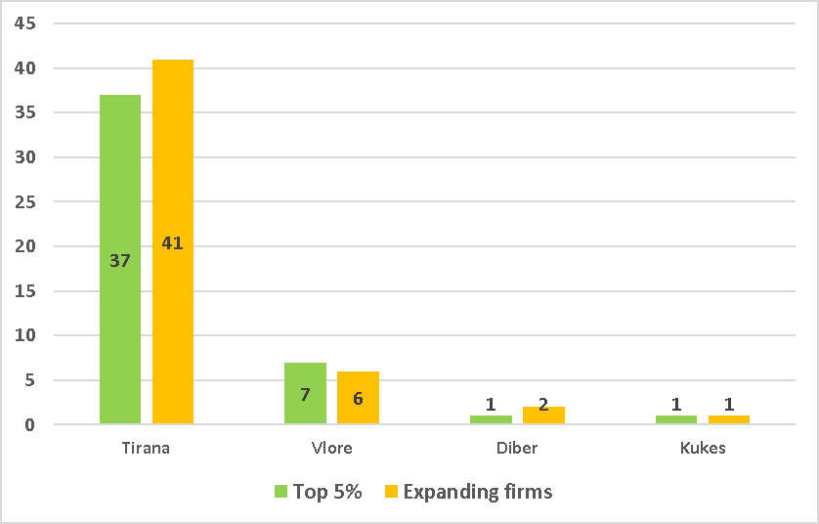
Graph 2.5 Number of “Gazelles” and “Expanding firms” fir the selection region (2017)
Chapter: SETTING THE SCENE (DESK RESEARCH FINDINGS)

Development of social economy in the four- targeted areas
The reintegration of women and girls VoT/PVoT/VoDV derives from the National Strategy Against Trafficking in Human Beings 2014-2017. Reintegration relates to action taken in the framework of preventive measures against retrafficking or trafficking or assistance measures to VoT/PVoT¹⁹. The European Convention on Action against THB requires state parties, including Albania, take measures to assist victims in their physical, psychological and social recovery. These measures are to take account of the victim’s safety and protection needs in cooperation with NGOs and other organisations engaged in assistance to victims.
In order to achieve the empowerment of women victims of trafficking, conditions have to exist for them to become economically and psychologically independent. This is depends on opportunities for work, education and training, and the way in which service providers’ work with victims.²⁰
There are government programs contributing to positive measures attempting to bridge gaps between socially-excluded individuals who have suffered from a trafficking experience. The legal provisions establish a comprehensive programme of socio-economic reintegration which includes social, legal assistance, health, safe accommodation and implementation of educational, and work inclusion programmes.
- DCM No. 27, dated 11.01.2012 “On the employment promotion programme for women and special- needs groups”
- DCM No. 48, dated 16.1.2008 “On the employment promotion programme of unemployed job-seekers who are at difficulty”
- DCM No. 47, dated 16.1.2008 “On the employment promotion programme through development at work”.
Albania does not have specific legislation regulating social businesses. The law on not-for-profit organisations recognises the right of NGOs to carry out economic activity which serves the mission and the goals of the organisation.²¹
According to the 2014 National Report²² on the development of social business in Albania, in order to curb poverty, social business building could be a vital option for VoT/PVoT/VoDV. Social businesses could focus on collecting, processing and providing the market for the sale of organic products with high quality.

¹⁹ Anti- Trafficking Strategy 2014-2020
²⁰ National Action Plan for the Socio-Economic Re-Integration, 2016
²¹ Article 3, Law 10376/2011 on the establishment of NBS

NGOs in Albania give initial employment advice and information on the local labour market. According to information from D&E, Vatra and Another Vision some women VoT/PVoT/VoDV have already followed the option of creating social businesses. Although there are instances of successful female entrepreneurs, it is still too early to assess the success and the sustainability of such efforts and to draw a final conclusion whether the path of social business is more a viable option than business enterprises²³.
Chapter: SETTING THE SCENE (DESK RESEARCH FINDINGS)
Access to loans and other sources of financing is essential for entrepreneurship and business development. Small loans (micro-credits) are, therefore, an essential part of women’s initiatives to set up their own business. Micro-enterprise support has consistently been a component of IOM’s programmes and donor support for VoT/PVoT/VoDV and PVoT/PVoT in Albania.
Micro-enterprise support has consistently been a component of IOM’s programmes and donor support for VoT/PVoT/VoDV in Albania. These programmes play an important role in the reintegration of victims of trafficking as they are provided with financial resources and training in entrepreneurial skills to be able to follow the path of self-employment. By improving the financial situation of VoT/PVoT/VoDV /PVoT/PVoT, their families benefit as well and jobs are possibly created for family members and local communities.
It should be considered that the majority of the target population lives in rural areas and their income is generated mainly by agricultural activities, but the potential in this sector is not appropriately realized. In this context, improving access to markets and strengthening the quality of product delivery will create opportunities.
Recent government programs aim at supporting women entrepreneurs with a Women’s Fund and a Start- Up Fund.²⁴ This can be used for farm productivity which has been low due to high input prices, low levels of mechanization in the agricultural process, etc. Because Albanian remains a net agricultural importer due to the imports of the country being 7 times higher than the export rate, it has become difficult for the domestic agricultural and food sector to become more competitive²⁵. Challenges to the agriculture and livestock sector like food safety and meeting standards for the consumer are being addressed by various IPARD projects, GIZ.²⁶
The production is mainly for self-consumption or is traded at the local markets and characterised by high informality. The on-farm processing suffers from poor compliance with hygiene standards due to inadequate facilities and basic equipment and low levels of knowledge about new technology and hygiene standards²⁷. Table below list the Advantages and Problems faced by the agriculture sector.

Table 2.6 Advantages and Problems of Agriculture sector

Advantages | The direct problem | The barriers to the quality and efficiency of agricultural production
Competitive products, nuts, snacks, potatoes | Irrigation system | High transport cost
Competitive Price | Agricultural mechanics | Collection points
Increasing interest in domestic products | Performance | Food safety
Border market | Farm size

²² Ardita Bonatti, et.al.,NBS - Nxitja e Biznesit Social, Social Enterprise, Social Innovation and Social Entrepreneurship in Albania: A National Report, 2014, EFESEIIS
²³ National Action plan
²⁴ http://www.aida.gov.al/
²⁵ Employment and Skills Strategy 2014-2020
²⁶ Composed with information provided from Kukes Analysis of Economic Development and Public Services
²⁷ IPARD II

Export Potentials | Credit
Chapter: SETTING THE SCENE (DESK RESEARCH FINDINGS)

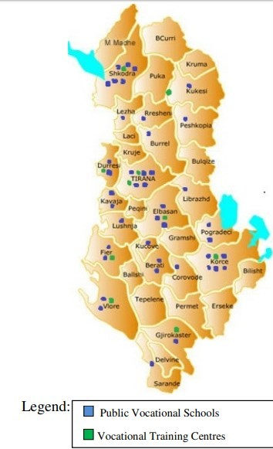Overview of the existing vocational and training employment programmes addressing the needs of potential victims of trafficking in the four-targeted areas in Albania
As cited from the National Action Plan for the Socio- Economic Re-Integration of Women and Girls Victims of Trafficking on the Republic of Albania: “To achieve the empowerment of women victims of trafficking, conditions have to exist for them to become economically and psychologically independent. This is subject to opportunities for work, education and training, and the way in which service providers work with victims” (p14).
There are currently 50 technical vocational schools (41 public and 9 private) and 10 public vocational training centres mainly located in urban areas. They are spread in almost all regions, with a higher concentration in central Albania²⁸. There are 340 private businesses or training providers licensed by the Ministry of Health and Social Welfare (MoHSW) and 30 operating as vocational training centres.

Figure 1. Geographic distributions of public vocational schools and vocational training centres in Albania ²⁹

The Regional Directorates of Vocational Training cover four main target groups (categories):
- Jobseekers registered at the employment offices;
- Persons out of work who are not registered at the employment offices;
- Employed people who want to update their skills;
- Economically inactive people (students, etc).

The “Employment and Skills Strategy” states that the public vocational training centres offer both short (4-6 weeks) and long courses (up to seven months). These courses target mainly unemployed individuals (either registered with the National Employment Service or not), but courses are open also to workers based on their qualification needs. Despite some progress, much remains to be done to improve the capacity of the National Employment Service (NES) to carry out all the functions of a modern Public Employment service throughout the country. This includes work in rural areas which are at a great need. The reforming process of the NES aims to transform it into an entity with budgetary and administrative autonomy, with modernized labour offices and systems of employment insurance, with efficient employment promotion programmes and vocational training that relates to the needs of economy, and with well trained staff in the headquarter and regional level capable of managing the modernized IT system.

²⁸ Employment and Skills Strategy 2014-2020
- Ministry of Labour, Social Affairs and Equal Opportunities, 2013-2020

The adult training provision is realised through a network of ten public vocational training centres, under the aegis of the MoHSW. The major training provider in Albania for adults is enterprises through on-job trainings and specific courses of duration from 1 to 3 months. A web VET Portal is in place. Although there is need and opportunities for VSs to offer short-term courses, for the time being, only Kamza Multi- Functional Centre (MFC) is currently doing this due its special legal status as a pilot multifunctional center.
Chapter: SETTING THE SCENE (DESK RESEARCH FINDINGS)
Medium and large enterprises are most active in training provision and the larger training is provided in trade, car repair, extraction, and energy and processing industry. “Skills for Jobs” research, reports³⁰ for the selected sector VET offer, there are a total of 12 professional directions, and 20 short-term courses preparing qualified employees for occupational profiles in ICT, construction, tourism, and textile sectors.

Economic sectors vary by the number of respective VE directions, profiles and training courses offered by the formal public VET system. Female representation in vocational education is generally low. The same source evidences that VET offer for tourism sector is limited to one professional direction, tourism and hospitality. This training is available at 10 providers in the Tirana, Durres, Shkoder, Elbasan, Vlora, Berat and Korça regions. There are also six different vocational training courses offered for these sectors: bartender, waiter, cook, tourist operator, pastry, and receptionist. Cooking is the most requested training course and is available at almost all VTCs. The report finds that the main sources of information to learn about the VET center are friends and relatives (72%). The second most relevant source is reported to be the employment offices (26%), a factor exclusive of VET trainees and not relevant to VET students. Graph 6 demonstrates that the percentage of students in vocational schools will experience a 55% decrease between 2013 and 2020.

Graph 2.6 Enrollment projection in Grade 10 (2013-2020)
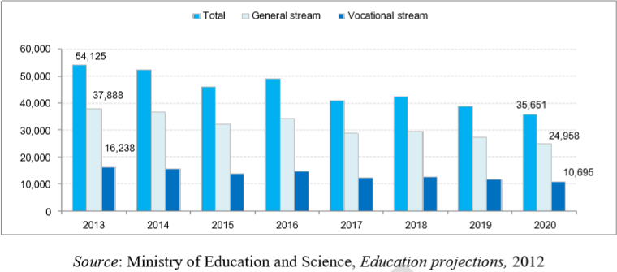

  - Overview and evaluation of the specific characteristics of the former victims of trafficking and of the challenges and obstacles that might hinder them in accessing the labour market
The government has taken the lead on victim protection efforts. Among the efforts to improve the initial identification of potential victims was the establishment of three mobile units in Tirana, Vlora and Elbasan,

- IDM (2016), “Skills for Jobs” research report, Commissioned by SDC

which enhanced the relations with those organizations that are in touch with individuals who may be victims of trafficking.³¹
Chapter: SETTING THE SCENE (DESK RESEARCH FINDINGS)
The government and NGOs identified 105 potential trafficking victims in 2017 (95 in 2016). Of these, 49 were adults and 56 were children (51 adults and 44 children in 2016), 80 were female and 25 were male (84 females and 11 males in 2016), and nine were foreigners (eight in 2016). Seventy-nine were identified as potential victims and 26 officially identified as victims (62 potential victims and 33 officially identified victims in 2016).
The national action plan for VoT/PVoT (2016)³² states that there is no comprehensive quantitative and qualitative baseline study on the socio-economic re-integration of women and girls in Albania. However, some information can be retrieved from documents of Anti-trafficking Strategy, the GRETA Country report, NGOs working with VoT/PVoT, studies conducted by IOM, etc. According to ONAC, in 2014, the majority come from poor regions, both urban and rural, mainly from Tirana, Durrës, Elbasan, Shkodra, Berat, Vlora, Korça, etc.
The reintegration of women who are victims of human trafficking into the labour market experiences must navigate many difficulties including the following:
- Individual factors.
- Social factors
- Institutional factors
- Factors of the market
Among other variables³³, women’s empowerment is correlated with the possibility of their entering the job market. Economic empowerment for women and girls PVoT/PVoT/VoDV is of paramount importance. It is a crucial factor in combating the probable root causes of trafficking: poverty and lack of economic means. Empowerment can be described as “a process through which an individual can develop his/her ability to stand independently, make his/her own decisions and show control over his/her life”³⁴

Domestic Violence
The Albanian Demographic Health Survey Study (DHS 2017-2018)³⁵ analyzed “Women empowerment” in relation with different variables. The study suggests that urban, married women are more likely (8%) to decide for themselves how their earnings will be used compared to rural women (6%). The proportion of married women who decide how their cash earnings will be used varies greatly by prefecture with a low of 2% in Diber and a high of 22% in Vlore. The same source finds that 3% of married women have experienced intimate partner violence, 2% have experienced such violence during the last 12 months and 1% have had injury.
The USSD HR Report 2017³⁶ noted that, ‘Domestic violence against women remained a serious problem. The UN also noted that in the period January to August 2017, 2963 cases of DV were reported to the police. ‘In October 2017 Kukes Police Department noted that so far this year, they had identified 26 cases of DV. The Tirana Legal Aid Society stated that around 2000 POs had been issued in 2017 up to the end of October [2017].

³¹ http://publications.iom.int/system/files/pdf/social_inclusion_albania_en.pdf
³² National Action Plan for the Socio-Economic Re-Integration, 2016
³³ Chioda Laura, Work and Family- Latin American and Caribbean Women in Search of a New Balance. The International Bank for Reconstruction and Development. World Bank, 2011
³⁴ Good practices in the EU on integration of VoT/PVoT, pg. 13
³⁵ ALDHS 2017-2018
36https://assets.publishing.service.gov.uk/government/uploads/system/uploads/attachment_data/file/764259/Alban ia_-_D.A._-_CPIN_-_v3.0 December_2018 .pdf

In the 2018 report on Albania the European Commission stated that, ‘During 2017, 3 243 cases [of domestic violence] were reported (against 3 700 in 2016) and 2 593 protection orders were issued (against 2 207 in
Chapter: SETTING THE SCENE (DESK RESEARCH FINDINGS)
2016). For 2017, 129 of these protection orders were not respected (against 119 in 2016).³⁷’
When considering women’s attitudes toward their beating, the graph below shows the percentage of all women age 15-49 who agree that a husband is justified in hitting or beating his wife for specific reasons(Graph 7)³⁸. Nevertheless, the proportion of women and girls age 15 – 49 who agree with one or more justifications for wife beating has declined from 30% of women in 2008-09 to 7%.

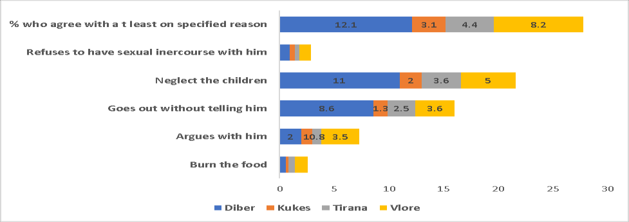
Graph 2.7 Percentage of women who accept and justify the cited reason for hitting (2017)

Overview and evaluation of the market needs that former victims meet now
According to UNWOMEN, women in Albania play an important role in two main sectors of the economy: services and agriculture³⁹. The promotion of agricultural production through the reduction of costs, increase of competitiveness, and the rise of employment are major objectives of National “Employment and Skills Strategy 2014-2020”. The Government Program foresees several measures that will address the agriculture development bottlenecks.
Medicinal and aromatic plants (MAPs) are an export-oriented sector with traditions, developed markets and good potential for growth (more than 95% of collected/produced MAPs are exported). The most important export products are sage, oregano, thyme, lavender and savoury. A small but increasing flow of export of essential oil is also recorded because the processing capacity in the country is also increasing. The production base consists mostly of wild MAPs available all over the country. Wild MAPs collections are more developed and organized in mountainous areas. In some areas in Northern Albania (Malesia e Madhe, Kukes and Diber) MAPs harvesting and cultivation accounts for between 30% and 40% of the income of rural families. There are around 20 small processers-exporters operating in the MAPs sector in Albania and 10 medium to large processors/exporters⁴⁰.
The production capacity and output of honey has also been increasing. The honey is mainly produced for the domestic market with small quantities exported. The beekeepers of the Vlora region, especially in Saranda, are the most consolidated and market oriented.

37 ibid
38 ALDHS 2017-2018
³⁹ Albania’s economy is dominated by the service sector, followed by agriculture which continues to be the largest employer Maria Elena Ruiz, Abril, “Getting Economic Policies Right for Women in Albania:
⁴⁰Medicinal and Aromatic Plants. Mini-Sector Study, Final report, 2014.The study was prepared by the Project “Preparation of Inter- sectorial strategy for agriculture and rural development in Albania”, funded by the European Union and facilitated by the FAO.

On-farm processing of agricultural products is very common and provides an important part of rural household incomes. Traditional livestock products include yoghurt, butter, curd and different kinds of cheese from cow, sheep and goat milk. Thus, sheep and goat milk are processed in the mountains, due to the lack of infrastructure for transportation of fresh milk to collection points.
Chapter: SETTING THE SCENE (DESK RESEARCH FINDINGS)
Tourism has grown significantly in Albania over the past years. Rural areas in Albania offer possibilities for the development of rural tourism, ecotourism and nature-based activities. There are successful projects implemented in Shkodra and Kukes, supported by GIZ, combining upgrading of accommodation, development of services and active promotion.
Rural areas near the southern coast have a great potential to attract tourists by providing on-farm tourism activities and facilities for leisure and recreation, e.g. Saranda, focused on integrating sea tourism with agro/rural tourism and cultural tourism based on UNESCO World Heritage site at Butrint. Local hand-crafts have long traditions and can enrich tourism experience, preserving and developing cultural, artistic and historical traditions and creating incomes in rural areas, if integrated with tourism development.
The IPARD II programme will be complementary to donor funded projects which are coordinated through the mechanisms of donor coordination i.e. joint German-Danish project for support to agriculture and rural economic development in disadvantaged mountainous areas (SARED). This was implemented in the 2014- 2018 period with focus at development of value chains in six rural mountain regions: Shkodra, Kukes, Dibër, Korce, Berat and Elbasan.

Overview and evaluation of the training needs to address future additional labour market needs
Businesses in agriculture and agro-processing, textile and foot wear, tourism, construction, transport and communication, energy, and information communication technology lack specialists and technicians. ⁴¹
Nevertheless, the relations between the vocational education and training system and industry are weak and most curricula offer little scope for practicing the skills learned. Although some concepts on learning about entrepreneurship have been introduced so far, no serious training on entrepreneurship in terms of self-employment nor starting a new business is provided; this is crucially important considering that more than 96% of businesses in Albanian are SMEs.⁴² Lifelong learning opportunities and the possibility for early school leavers and low-skilled workers to increase their job competencies are still limited both in quantity and quality. The vocational education and training services do not reach the rural areas. Currently, most of the Albanian population still live in the rural areas and the educational attainment of the rural population is lower than in the urban areas for all age groups.⁴³ The effectiveness of labour market measures will be enhanced through the provision of employment services for all individuals registering with the National Employment Services (utilizing self-service, group counselling and job search training).
For social inclusion purposes, the focus of the current Jobs and Skills Strategy centers on three policy areas.
- First, the reform and expansion of the National Employment Service will be key to improving both labour market attachment and employment prospects for population groups at risk of marginalization.
- Second, higher productivity in the agricultural sector will spill over into the food production chain thus increasing off-farm employment and earning opportunities for individuals living in rural areas.
- Finally, the reform of social safety nets will improve the equity, efficiency and effectiveness of the social protection system, which will reduce leakages and targeting errors thus freeing resources to expand coverage and the level of benefits. Brochures will be published about employment services offered.

⁴¹ Rama and Matja (2012) “Sector Skills Needs Analysis in Albania.” UNDP, Albania
⁴² Employment skills Strategy
⁴³ ibid

METHODOLOGY (FIELD RESEARCH)
Chapter: METHODOLOGY (FIELD RESEARCH)

Sampling procedures and participant recruitment for focus groups and interviews
The methodology used for this assessment included different types of information gathering and analysis. A desk review, a fact finding mission from the lead consultant, and fieldwork done by the local partner were the main activities for the data collection process. The information was collected through semi-structured interviews, surveys and focus group discussions that were designed by the lead consultant, adjusted during the field visit and applied by the local partner.
In order for the data collection process to be representative of the country in terms of regional and ethnic differences as well as rural and urban areas, four study units were randomly selected based on the knowledge and advisement of key national stakeholders. The project study areas were: Tirana, Kukes, Peshkopi and Saranda. The process followed the steps below:
- First was the strategy of “exploring the scene.” The identification of main “actors” helps us to better understand the current state of unemployment rates, existing economic activities, and development of the social economy in the four targeted areas.
- Field visits. Study units were organized in the four target areas to collect data based on the knowledge and advisement of key national stakeholders.
- Observation. Observation. Observation was used to find the differences between the regions. Findings included information about the capacities for employment for the victims of trafficking and violence, existence of job-training skills, or their training for employment or self-employment. It is understood that the problems of the target group are the same in all regions studied, but the resolution gap for their recovery in the labour market is different.
Focus groups utilizing a semi-structured interview format was the principal technique used to explore issues of interests and the responses of individual respondents. Based on the researchers’ desk analysis, guideline questionnaires were structured to help yield the information from various levels of stakeholders. Focus groups planned for each region were as follows:
  - Four Focus Groups with relevant stakeholders: one per target area—with at least eight participants each.
Profile of the participants: representatives from different sectors in the four target areas were present because their role can provide input in the labour market needs analysis
Outputs: invitation, agenda and consent form in national language, signed attendance list, focus group report in English.
  - Fifteen Individual face-to-face interviews or telephone interviews with local business/employers, chambers of commerce, vocational training providers, employment agencies, CSOs and other local stakeholders per target area.
Methodology of the individual Interviews
  - Interviewees were selected in a way that is representative and eligible for the project categories.
  - The interview questions were developed by the research experts’ team, according to the interviews guide and close consultation with D&E.
  - All interviewees were provided with information about the project in their national language. The researcher asked the interviewee to sign a Consent Form (Annex 1) in their national language and provided them with any ID data and/or personal contact information. The Consent Form is also signed by the interviewer/researcher. All interviews took place in an appropriate environment. Interviewees selected a place where the interview was conducted.
Instruments

Questionnaires were the instruments used for semi-structured interviews. This method was used to gather focused, qualitative textual data. Questionnaires were designed based on desk work analysis and are composed of a set of open-ended and close-ended questions. They are technically built to yield verifiable quantitative data which can be used to identify deficits, omissions or gaps existing.
Chapter: METHODOLOGY (FIELD RESEARCH)
Qualitative data was gathered through interactions with the focus groups. Similar questions were posed to all focus groups in order to gather information on topics including, but not limited to: development of vocational training priorities, programs for former victims, and programs that will help them tap their business potential. This instrument was designed to gather in-depth information about respondents’ attitudes and knowledge as well as their experiences in improving the quality of VoT/PVoT/VoDV capacity building and social integration processes.
The one on one interviews involved a set of similar questions related to efficiency, effectiveness, training ownership, sustainability and impact, the perceptions of stakeholders about VoT/PVoT/VoDV, gender and non-majority issues, etc. However, the questions were tailored from one key respondent to the other to more closely align with his/her current business responsibilities and/or role.
All instruments were administered in the form of individual face to face interviews and the focus group/meetings discussions to gain in-depth understanding of the issues. Variables selected to analyze the elements of effectiveness were explained to respondents prior to the interview.
Overall, the methodology outlined above, with its mix of qualitative and quantitative data collection methods, helped to build a comprehensive picture of the obstacles deriving from the training needs program that impact VoT/PVoT and VoDV skills and responsibilities required. The analysis of the resulting data is presented in the following chapters.

a. Social and demographic characteristics of the respondents in focus groups and interviews
Interviews (Interviews with focus groups & interviews with private/public sector). Sixty structured interviews were conducted with service providers in the four units selected for the study. At the national level, the lead consultants did a total of 60 interviews with different key actors of the national and local governments as well as public and private service providers. The following was the final distribution of the surveys

Table 3.1 Structured interviews, regional sampling and urban vs. rural

Study Units | Urban | Rural | Total
Tirana | 27 | 6 | 33
Kukes | 13 | 4 | 17
Peshkopi | 4 | 2 | 6
Saranda | 2 | 2 | 4
Total No. of surveys | 54 | 4 | 60
Table 3.2: Data
related to focus group meetings in 4 regions

Focus Groups in Tirana
- 8 FGDs with women
- SME companies from different sector of industry
- Public sector ( National Employment Office )
- NGO with similar projects on helping target personas

o Chamber of Commerce
Focus Group in Kukes
- 13 FGDs with women & men
- Public Sector (Local Employment office) Participants: mix groups (with participants from rural & urban areas)
- Employments Service structure; Public Social Services
- National Employment office (Regional Office work in Kukes)
- General secretary of anti-trafficking at the regional office
- Specialist of INSTAT
- Distribution company
Focus Group in Peshkopi
- 12 FGDs with women& men
- Public Sector & NGO-s
- Private sector (SME companies)
Focus Group in Saranda
- 8 FGDs with women & men
- NGO-s
- Private sector
- Regional Office work in Saranda
Chapter: RESULTS (FIELD RESEARCH)

RESULTS (FIELD RESEARCH)
The fieldwork was organized by D & E staff members in cooperation with local structures, mainly with regional employment offices. During the field visits, discussions were held in focus groups as well as direct interviews with representatives of different subjects. Field findings, both by focus groups and individual interviews, will be reflected in the following. This part of the report consists of i) Findings of the focus groups; ii) Findings of the interviews with victims of trafficking; iii) Findings of the interviews with the other actors involved; iv) Common and different aspects between the interviewees; v) Gaps, challenges and best practices identified through the focus group and the interviews.

Findings of the focus groups
In Diber, Kukes, Tirana and Saranda, the project "Research on local job market skills needs & opportunities to inform the development of vocational training priorities and programmes and business development potential for victims" was completed by a focus group. In these FG participated representatives from D & E, three contracted consultants and representatives from: a) Government Sector; b) Business sectors; c) CSO organizations/Social Business. Representatives from D & E and three contracted consultants and representatives from the government sector, business sector, and CSO organizations/social businesses participated in these focus groups. It is interesting to note that there was satisfactory interest and participation from representatives of different institutions and subjects in each of the four target areas of Dibër, Kukes, Tirana and Saranda. Satisfying desired participation numbers was also accompanied by an active participation in open discussions about their experiences and opinions of the target groups VoT/PVoT/VoDV.

In each of the regional FG, participants were D&E representatives, three contracted experts, and, most importantly, local actors. It is very important to mention that number of participants that were local actors was over 8 in each site and the women were the dominant presence⁴⁴.
Chapter: RESULTS (FIELD RESEARCH)
To achieve this goal, actors from various public entities (regional employment offices), local businesses and civil society organizations were invited. The discussion was intended to address the challenges and obstacles that could hinder empowerment and access to the labour market for the target group.
The participants at the FG’s formed a diverse and complementary group of local people whose profile represented areas and sectors of interest. The meetings were opened with a presentation of the purpose by the representative of the D & E organization and continued with a short presentation of all the participants. Subsequently, the consultants provided all the participants with information on the project and requested consent through the signed consent form (in the national language). All participants discussed the activities of the institutions they represented throughout the presentation. Following, the consultants encouraged all the participants to participate in discussions focused on three main directions:
    - The current employment situation in this area;
    - Prospects and future trends in employment;
    - What should be done for VoT/PVoT/VoDV to have more employment opportunities in the future?
Participants in this focus group discussed openly about the current situation in their institutions regarding these three topics. The focus was on the general presentation of the number of employees, the annual report of the employees, and their plans for the future, especially relating to the increase of in their numbers of employees. VoT/PVoT/VoDV involvement in employment opportunities was particularly emphasized as well as what should be done in advance for these individuals to be more prepared for the workplace.
It was clear from the discussions that there are efforts from different levels and sectors to support the target group of VoT/PVoT/VoDV, but the identification tools for this group still appear to be weak and sporadic. It is clear that the business sector has great potential for opportunities to support VoT/PVoT/VoDV with economic empowerment through employment. However, there is a huge gap in the ability to enter this target group into the labour market successfully. Large businesses primarily use the organization’s website as a communication tool and communicate with their partner. Snowball is also used to achieve the required profile HR. Both of these methods are not favourable to notify the VoT/PVoT/VoDV populations for the extent that it is needed.
When considering the supply side, CSO’s with a particular focus on assisting low-income households (in particular, orphans and women-headed households) face limitations and difficulties in accessing and exploring market opportunities in order to increase the employment opportunities for VoT/PVoT/VoDV. The supply and demand link should be varied and efficient, but the marketing sector does not reach this demand at the required level.
Civil society organizations are not great in number and their activity is relatively limited. While those organizations that support women to create and promote economic activity are willing to contribute to VoT/PVoT/VoDV employment, they have not had proper prior experience to help this category. CSO connectivity tools to the target group remain a concern in this area because it also requires a greater commitment to capacity building and building lasting partnerships.
Generally speaking, the market chain does not work well and the low economic power does not allow the target group to reach the stage of successful sales of their product. Also, these groups are limited in terms of knowledge and information on how to better organize and rely on their investments.

⁴⁴ Please refer to the participants list of FG

From the participants' discussions in this FG, it emerged that the target group VoT/PVoT/VoDV demonstrates a lack of knowledge and skills in responding to market demand and quality. Businesses operating in the area (relatively consolidated) have high recruitment requirements for candidates. For this, they informed the participants that they offered VET training courses to train individuals interested in hiring in their sectors.
Chapter: RESULTS (FIELD RESEARCH)
One important element that emerged during discussions during the FG was that the businesses of the area do not have any prejudice against VoT/PVoT/VoDV or issues with hiring them. Businesses only have the requirement that a candidate, VoT/PVoT/VoDV or not, have the right knowledge and dedication for the job

Findings of the interviews with victims of trafficking
The global survey index by the US State Department shows that on any given day in 2016, an estimated 3.6 million men, women, and children were living in modern slavery in Europe and Central Asia. This region had a prevalence of 3.9 people in modern slavery for every 1,000 people in the region. When considering the forms of modern slavery, the rate of forced labour (3.6 per 1,000 people) was higher than the rate of forced marriage (0.4 per 1,000 people). The prevalence of forced marriage was the lowest of all the world’s regions. A little over a third of victims of forced labour exploitation were held in debt bondage (36 percent) with a higher proportion of men trapped through debt.
The region also accounted for 14 percent of forced sexual exploitation worldwide. These regional figures, while important, should be interpreted cautiously given the gaps and limitations of data in key regions. For example, there are numerous reports of forced marriages in Central Asia but few surveys on the issue have been conducted there; this contributes to lower rates of forced marriage than may be the case in this region. Albania is ranked 5th in the region. Whereas the estimated prevalence of the victims (victims per 1,000 populations) is 6.9, the estimated absolute number of victims is 20,000 out of a total populations 2,923,000⁴⁵.
Statistical data from the Office of the National Anti-Trafficking Coordinator/Interior Ministry for 2017 shows that there are 105 identified victims of trafficking (female, male, adult, juvenile, Albanian or foreign), out of which 26 VT and 79 VMT, 25 men and 80 women, 49 adults and 56 children, 96 Albanians and 9
foreigners (1 Filipino, 3 Afghans, 1 Kosovo, 1 Italian, 1 Belarusian, 1 Romanian and 1 Macedonian). Most of the victims identified during the reporting period are women and girls. The age of female/female victims varies: 18-20 years old-18 VoT/PVoT/VoDV; from 21 to 30 years-21 VoT/PVoT/VoDV and from 31 years and over 10 VoT/PVoT/VoDV. The destination countries for the identified victims were: Kosovo, Macedonia, and the EU countries: Greece, Italy, Belgium, the Netherlands, Germany, Switzerland and Norway.
Women or girls who are VoT/PVoT/VoDV have difficulty expressing the suffering and the problems they face with their lives. However, they have the courage and the ability to improve their mentality and use as many subjects and resources possible in overcoming their difficult situation.
Bad medication or treatment ban, home-based isolation, lack or difficulty in finding basic services or specific types of physical violence exercised on women and girls are some of the serious difficulties VoT/PVoT/VoDV face in our country. The threat of abandonment by a family member, the control of any behaviour and movement, and the threat of being sent to an institution outside the home and the family's warmth are examples of emotional violence exercised in the VoT/PVoT/VoDV context.
Economic violence was also a major barrier of the free livelihood of this community. This was the case where social assistance payments or their economic aid were managed by the family or spouse or were not used for problems related to their situation. This vicious cycle of violence initiated by the family or spouse continues when women and girls face shortages of services by not allowing their treatment and rehabilitation.

⁴⁵ Estimated prevalence of modern slavery by country, Europe and Central Asia

A report published by the Council of Europe on Albania found that uneducated women in peripheral and poor areas of Albania are the most common victims of gender-based violence, revealed a report published by the Council of Europe on Albania. The Group of Experts on Action against Violence against Women and Family (GREVIO), however, assessed that other Albanian women (despite education) are victims of domestic violence. Because of the values of traditional families, there is a tendency in Albania to promote forgiveness and to tolerate violence to keep the family together, which makes the women within the family vulnerable.
Chapter: RESULTS (FIELD RESEARCH)

Findings of the interviews with the other actors involved
Individual interviews in the four regions were an important part of the study, and these interviews yielded interesting data about the current situation as well as VoT/PVoT/VoDV related treatment. Individual interviews developed in the four program regions (Tirana, Kukes, Diber and Saranda) were conducted with:
- Businesses of different levels ranging from family business, small business, middle to big business. These businesses operated in diverse and varied areas such as services, cafes, hotels, private schools, construction, dental services, food processing, agro-business, crafts, tourism, etc. The number of employees in these institutions interviewed varied from 1 to more than 50 employees with their annual reports stating that the percentage of staff that were women was from 0 to 100%.
- Different civil society organizations focused on different fields but who are interested in being part of the VoT/PVoT/VoDV support activities. Even in these civil society organizations, their size ranged from 2-3 staff to over 20 with the percentage of staff that were women being up to 100%.
- Public institutions, mainly employment offices, the relevant sector in the respective municipal offices as the institutions tasked with taking measures to assist VoT/PVoT/VoDV persons.
- Individuals who have been part of the trafficking and who have entered their "revival" and "normal" life.
Because of the variety of interviewees, the information gathered helped to create understanding of the current business situation and trends in terms of growth and increasing the number of employees. The interviews also helped to distinguish the requirements of the employing institutions (mainly business companies in the country) regarding the level of education of the jobseekers (VoT/PVoT/VoDV) as well as the professional knowledge and skills that employees are required to have.
Most of the interviewed businesses indicated that they did not have a particular office to deal with staff recruitment, but in general it is one person who does this job. In some cases, this person may be in charge of other work. In many of the interviewed cases, the manager was the person who recruited staff. The interviews also found that, in most cases, companies do not conduct their own in-depth studies of the market; the companies refer to data gathered by public institutions.
Throughout the interviews with the representatives from companies it was determined that companies, in general, have their own social policies as they know their employees, provide bonuses based on the realization of production rates, and they also give rewards at the end of the year. In most cases, it appears that in reality there is no indexation of the pages on the basis of inflation.
The company's main staff recruitment methods remain Labour Offices, but references are also made by current employees or from the narrow circle of society. Companies included in the study claim that there is generally no strategy for marketing or clear marketing practices. Some of these businesses use social networks like Facebook, Instagram, Linkedin, but this is not a practical for everyone.
In the service sector focused on the coffee bars, restaurants, and hotels, recruitment is done through an open competition (after public announcements), but in some other cases the recruitment is still done on the basis of personal recognition by not advertising any position on the web, facebook, etc.

In the region of Tirana, the recruitment process is more formalized and social policies are more developed with page reassessment, economic aid for staff, awareness raising campaigns, etc. compared to the other three regions.
Chapter: RESULTS (FIELD RESEARCH)
While the banking and financial sector staff management and recruitment policies are developed transparently, the average staff age is 25-50, while 90% of the staff consists of women. This creates very good opportunities for VoT/PVoT/VoDV women, especially those with their respective education, to become part of the staff.
Through the interviews it was found that the workers who have been VoT/PVoT/VoDV, do not declare themselves as such, especially at the recruitment stage. But when women who have been VoT/PVoT/VoDV self-identify and recognize that they belong to this category, there is no bias in recruitment if they meet the basic soft skills requirements for employment.
Through the interviews, we further focused on relationships that are built with the group of violated and/or trafficked women. Thus, from individual interviews it has been reported that the businesses involved in the study generally have information about VoT/PVoT/VoDV competencies. However, only a small portion of these businesses have experienced employment of abused or trafficked women. Respondents who have had the opportunity to have employed abused and / or trafficked women in their institution stated that various issues have emerged.
Problems related to the behaviour of abused and/or trafficked women were different. The educational and professional levels of these candidates were a top concern for employers. In general, their novelty did not comply with job requirements and did not allow for their rapid involvement at work. For this reason, it is necessary to train VoT/PVoT/VoDV in work ethic but also with regard to the specifics of the profession in which they will be involved.
Among other elements related to their problematic involvement in work, there are cases when VoT/PVoT/VoDV employees bring their life and family worries to work. This creates a burden for these women VoT/PVoT/VoDV and the job they do, but also on other staff members. In other cases, VoT/PVoT/VoDV are not satisfied with their payment or have frequent absences from work.
In some cases, the phenomenon of prejudice and "non-acceptance" of women who are VoT/PVoT/VoDV has been reported. This is also the result of the social environment that appears in our country. Some of the business representatives involved in the study do not have plans for social programs or work spaces for VoT/PVoT/VoDV women.
But if we broaden the data obtained from the interviews, it turns out that there are two big concerns about VoT/PVoT/VoDV employment:
  - Finding information about vacancies;
  - Educational and qualification level of VoT/PVoT/VoDV as a job seeker.
Regarding the first point, respondents asked for more from the public institutions to facilitate the connection of the jobseekers (in this case VoT/PVoT/VoDV) with the employers. On the other hand, it is required that the category of violated and/or trafficked women work more with social networks and sites that make vacancies known.
While the second point requires more engagement in the following ways: i) obtaining as much information as to the level of education and knowledge in the various professional fields of VoT/PVoT/VoDV; ii) taking measures to include VoT/PVoT/VoDV in various professional courses, be it for the public or only for this category; iii) small-scale support that enable the free initiatives of these women.

Common and different aspects between the interviewees
Chapter: RESULTS (FIELD RESEARCH)
Almost all respondents acknowledged that assistance to women who have experienced a state of affliction or trafficking should be assisted by the state, by the business, by civil society organizations, and by the entire society. In reality only a portion of the interviewees have had cases where a woman from VoT/PVoT/VoDV was involved in their workplace. While most of them had not had experience with VoT/PVoT/VoDV women in their workplace, there was no clear strategy regarding the possibility of working in the VoT/PVoT/VoDV women's category.
Part of the respondents were in favour of the idea that women who were VoT/PVoT/VoDV could reintegrate into society and they should not be exposed or prejudiced. Meanwhile, another portion of respondents featured a differentiation element in the VoT/PVoT/VoDV women's category and admitted that they did not have full confidence in the reintegration opportunities of this women's category.
During the course of the study it was noticed that different representatives focused on the state's duty to women of VoT/PVoT/VoDV and requested state bodies’ full responsibility for this category. Meanwhile, others argued that the state has its irreplaceable role in preventing cases of trafficking or rape of women as well as in reintegrating them into society. On the other hand, they thought it was not just the state’s responsibility and they did not believe that the state could it solve all the problems. To achieve this goal, civil society organizations, businesses, donors and the whole society should be involved in this process.

Gaps, challenges and good practices identified through the focus group and the interviews
During the course of the study, there are a number of issues we were confronted with and that we will focus on, mainly in terms of gap, challenges and good practices.
Gaps. Despite the good work done by public institutions, based on the legislation approximated with developed countries and updated with the situation, there is still much more to do. The work still needed is mainly in terms of the extent of activity in suburban and rural areas. It is necessary to improve the work on the findings of the questions, but what remains a great concern is the assistance to VoT/PVoT/VoDV intended support the many problems that these women encounter.
On the other hand, it is important for the persons involved in VoT/PVoT/VoDV to be more active in relation to the declaration of their situation in the respective state bodies as well as their efforts to overcome the situation in which they have fallen. This is a very difficult thing for this category of women because in many cases they are physical, mental, and financial violated and are dependent on the uninhabitable housing of the children they have. The distance from the inhabited centre and/or potential work centre and infrastructure is still poor.
Civil society organizations, some of which are involved and interested in assisting and solving the problems of VoT/PVoT/VoDV women, do not have the necessary financial resources. On the other hand, women's issues of VoT/PVoT/VoDV are so wide that it is not possible to address only civil society organizations.
Among the main issues of women of VoT/PVoT/VoDV deciding to rebuild their life, the following should be considered: i) employment; ii) financial support to start an activity. The critical point is about the level of education and professional formation of these women. There is not much that can be done regarding the level of education, but there is still no clear plan for the professional formation of this category. Even small-scale support to start or expand a women's VoT/PVoT/VoDV entrepreneurship is still spontaneous and not enough for this category.
It is noted that, despite the work done by different actors and factors such as state institutions, civil society organizations, businesses or even women VoT/PVoT / VoDV and despite the positive cases of rehabilitation and re-engagement, the work done is fragmented, spontaneous and does not function properly utilizing the full chain. This does not lend itself for complete and successful action.

Challenges. A well-established legislative framework has already been developed that recognizes the gender-based nature of violence against women. It is necessary to make a lot of effort to effectively resolve all forms of violence against women including forced marriage, sexual harassment and sexual violence, as well as flagrant violence and / or trafficking cases. The authorities should consider the reasons for gender-induced violence against women instead of treating it only as domestic violence. Existing mechanisms that relate to the lack of enforcement of protection orders, inadequate decisions by the court system and insufficient involvement of health professionals and forensic experts are considered as challenges for our country.
Chapter: CRITICAL ANALYSIS OF FINDINGS
The Albanian society still remains a society that is not sufficiently supportive and unambiguous to VoT/PVoT/VoDV women's categories. For this, it is important to move further towards the improvement of legislation in terms of strengthening the law enforcement institutions and in the direction of education, especially of the young generation, in relation to the support and solidarity with this group in society.
On the other hand, it is important to address two important issues related to VoT/PVoT/VoDV women when they decide to rebuild their lives: i) employment; ii) financial support to start an activity. With regard to employment, VoT/PVoT/VoDV women are required to be included in specific courses aimed at raising their vocational skills. While in terms of financial support, help to start or expand a women's VoT/PVoT/VoDV entrepreneurship venture has to deal more with both the state and the donors.
A highly marginalized category remains VoT/PVoT/VoDV women who live in rural or suburban areas as the opportunities for starting a new life for these women are even more difficult. This is related to the infrastructure, the mentality, but also fewer opportunities for both employment and self employment.

Good practices. A welcomed change would be treating problems related to violence and/or trafficking as a permanent issue to be analysed and for the counties and municipalities to take action regarding these issues. Periodic meetings and reporting on the situation in the chain process once every three months is an important element in the implementation of legislation regarding violence and trafficking of women in our country.
The work done by some civil society organizations and donors in addition to the work done by the state bodies is an example that needs to be recognized, but the work also needs to be improved. The improvements should mainly be related to training, investment in assisting this population, and financial support.
The cases of businesses supporting the women VoT/PVoT/VoDV have shown that employment of women in this category is entirely possible. On the other hand, women's VoT/PVoT/VoDV efforts to leave behind the critical situation and the negative experience that have passed and to engage in normal life are examples that need to be broadened.
Efforts made by women in rural and / or suburban areas to raise their "business" are a good opportunity for VoT/PVoT/VoDV women. In order to be successful in these ventures, these women require start-up assistance and training and mediation to connect contacts with concrete persons/initiatives. The examples show that these women can emerge.

CRITICAL ANALYSIS OF FINDINGS
Reflect critically on the findings of the field research and link them to the desk research findings and the aims and objectives of the project.

There are specific organizations and authorities’ structures dealing with the VoT/PVoT or VoDV, but this organizations need further to expand their network in addressing the needs of the group under the target for not ending up to their projects or organization mission space.
Chapter: CONCLUSION AND RECOMMENDATIONS

Organizations have to think broader in regards to the behaviour change of VoT/PVoT. Their skill capacity should not remain only in professional development but also in ethical and personal behavior.

Businesses, in particular in the large urban areas such as Tirana or Saranda, should not be seen just as a labour market; they have to be close counterparts for the VoT/PVoT and VoDV organizations for a better understanding of the needs and complexity of the issues related with target group.

Channels of information have to be tailored for reaching this specific group. This has to consider their level of education as a matter of serious concern with a large number of women and girls having only completed basic education (eight to nine years of schooling).

Based on their individual social status and level of education, their re-integration into the families, community, and society is a challenging process and requires targeted and careful interventions from anti- trafficking stakeholders. To optimize the investment, the efforts should be focused and tailored based on the VoT/PVoT and DVoT/PVoT actual situation.

CONCLUSION AND RECOMMENDATIONS
This study was conducted for a relatively short time and focused on 4 areas of Albania. Consequently, the conclusions and recommendations drawn from the study (which are in the following) will also show limitations (exactly related to the two quoted points). However, these conclusions and recommendations may serve as a good reference to building work in the future, mainly focused on VoT/PVoT / VoDV. Same of most important conclusions and recommendations’ (not limited to) are as follows:
- There are a number of interested (working with) institutions in VoT/PVoT/VoDV, however, it has not been sufficiently supported for the VoT/PVoT/VoDV individuals and/or their families.
- The labour market is a relatively limited market, however, there are VoT/PVoT/VoDV employment opportunities in different sectors suitable for this category.
- There have been cases of VoT/PVoT/VoDV employment, but they have not been very successful, mainly due to the specific conditions of VoT/PVoT/VoDV employed women. The example comes from hotels and tourism sector.
- Existing vocational training programs addressing the needs of potential victims of trafficking in four-zone areas in Albania are in place. The problem lies in the fact that market and information segmentation prevent chain linking to ensure a proper communication system. Regularly analyzing and revising the local vocational training plans of the VoT/PVoTs, PVoT/PVoTs and their families (in case of their re-integration in their family) may optimize the local investments in targeting the needs of VoT/PVoT.
- The social and family context of VoT/PVoT/VoDV is accounted for as one of the main challenges and obstacles that may prevent them from entering the labour market.
- There are cases that labour market requires personnel (at different levels including low qualified people) but, for most of the cases, motivation and willingness is missing.
- The individuals from VoT/PVoT/VoDV live in rural and urban areas and they both face difficulties, but those from rural areas face more problems including infrastructure and distance from job opportunities.

- Self employment for VoT/PVoT/VoDV such as doing handicrafts seems to be an opportunity, but there are a lot of difficulties at the start-up phase, including training and investments.
Chapter: CONCLUSION AND RECOMMENDATIONS
- The presence of the border with Greece, the ease of border crossing and the seasonal employment opportunities with good pay in some way affects the worries in the dedication for work for VoT/PVoT/VoDV.
- Businesses related with accommodation (Hotel) and services shows their will to cooperate with the government structure as well as with the CSO with specific focus on enabling the employment of VoT/PVoT/VoDV.
- Businesses can support the purchasing of products produced from entrepreneur vulnerable initiatives, but they have to be well structured and function within the local regulatory framework (financial and quality documents).

REFERENCES
Chapter: REFERENCES
- Blazyte G,. (2011) VICTIMS OF HUMAN TRAFFICKING (RE-)INTEGRATION INTO THE LABOUR MARKET IN THE CONTEXT OF THE EUROPE.
- Bonatti, A. et. al. (2014, November). Social Enterprise, Social Innovation and Social Entrepreneurship in Albania: A National Report. Tirana: EFESEIIS.
- Chioda Laura, (2011) Work and Family- Latin American and Caribbean Women in Search of a New Balance. The International Bank for Reconstruction and Development. World Bank.
- Europartners Development (2015). Analiza e Zhvillimit Ekonomik dhe Shërbimeve Publike, Final Report ALDHS 2017-2018 (2018 November), Ministry of Health and Social Welfare
- International Organization for Migration. (2012). Internal Review Micro-Enterprise Development Programme for Victims of Trafficking (2006-2011). Kyiv: IOM.
- International Organization for Migration. (2013). Business training guideline Economic empowerment of the victims of trafficking. Kyiv: IOM.
- International Organization for Migration. (2015, January). Migrant Assistance Division Newsletter 1st issue. Geneva: IOM.
- International Organization of Migration (IOM). (2007). The IOM handbook on direct assistance for victims of trafficking. Geneva: IOM.
- Job Dynamic in Albania (2018 May). A note profiling Albania’s labor market
- Lenja, V. (2015). Profile of the situation of trafficking victims and efforts for social inclusion. Tirana: IOM.
- Lyneham, S. (2014 September). Recovery, return and reintegration of Indonesian victims of human trafficking. Australia: IOM.
- Maria Elena Ruiz, Abril (2012), “Getting Economic Policies Right for Women in Albania: Policy Issues and options for Women’s Economic Empowerment” A Policy Issues Paper, UNWOMEN 2012¹Medicinal and Aromatic Plants. Mini-Sector Study, Final report, 2014.The study was prepared by the Project
- Medicinal and Aromatic Plants. Mini-Sector Study, Final report, 2014. “Preparation of Inter- sectorial strategy for agriculture and rural development in Albania”, project funded by the European Union and facilitated by the FAO.
- Ministry of Social Welfare and Youth (2014). Employment and Skills Strategy 2014-2020. “Higher skills and better jobs for all women and men”
- Ministry of Labor (2013), Social Affairs and Equal Opportunities, 2013-2020
- Ministry of Interior. Evaluation report on the implementation of the National Strategy Against Trafficking in Human Beings 2005-2007.
- Ministry of Labour, Social Affairs and Equal Opportunities. (2008). Standards of social care services for trafficked persons or persons at risk of trafficking in residential centres.
- Ministry of Social Welfare and Youth. National Strategy on Employment and Vocational Training 2014-2020
- National Action Plan for the Socio-Economic Re-Integration of Women and Girls Victims of Trafficking on the Republic of Albania (2016). Albanian Ministry of Interior
- National Institute of Statistics (2017). Vjetari Statistikor. www.instat.gov.al

- National Institute of Statistics (2017). Business Register . www.instat.gov.al
Chapter: REFERENCES
- http://www.instat.gov.al/media/4149/regjistri-i-ndermarrjeve-2017.pdf
- http://instat.gov.al/al/temat/statistikat-e-p%C3%ABrgjithshme-dhe-rajonale/tregues-sipas- bashkive/#tab2
- National Institute of Statistics (2017). Labor Force. www.instat.gov.al INSTAT
- Rama & Matja (2012) “Sector Skills Needs Analysis in Albania.” UNDP, Albania
- Re/integration of trafficked persons: supporting economic empowerment (2012). Issue paper #4 Trafficking Victims Re/integration Programme (TVRP)

Surtees, R., (2010). Monitoring anti-trafficking re/integration programmes. A manual 2010, NEXUS Institute, Washington
- UNWOMEN (2012). Policy Issues and options for Women’s Economic Empowerment” A Policy Issues Paper,

United Nations Programme “Support to Social Inclusion in Albania” (2015). Profile of the situation of trafficking victims and efforts for social inclusion. Tirana: IOM.
- Zona Funksionale e Kukësit (2015). Analiza e Zhvillimit Ekonomik dhe Shërbimeve Publike

ANNEXES

1. Questionnaire used for the individual interviewed

QUESTIONNAIRE FOR DATA COLLECTION
Greetings! My name is and I am an Interviewer on behalf of the organization "Different & Equal. This organization is implementing the project "Collaboration between CSOs and groups of former victims of trafficking and domestic violence for the economic empowerment of victims", funded by the European Union and implemented by the Family and Children Center (KMOP) and "Different & Equal". The purpose of the project is to facilitate the socio-economic reintegration of former victims / survivors of trafficking and domestic violence in Albania. The areas where the project is implemented are Tirana, Kukes, Dibra and Saranda. Within the project, a study will be carried out on the skills and opportunities that labor market provide for a small sustainable business in these areas and the skills that have or may develop the former victim’s survivors thanks to the project. To do this, we are carrying out a study in order to better plan and orientate work to assist women victims of domestic violence and trafficking in these areas. We would like to invite you to be part of this questionnaire that is intended to collect data, and all the information received (if you have no objection) will be confidential and will only be used for the purposes of this study.

SECTION I – General Information

Region
County
Municipality
Name of the interview
Age
Sex
Level of Education
Company/Institution
Current Job Position
Period in this Company/Institution

SECTION II - INFORMATION ON LABOR MARKET

- Which sector / industry does your company operate?
Chapter: ANNEXES
- How many employees have your company / institution /s?
- What is the average salary in your company?
- What is the gender ratio in your institution?
- What is the average staff age?
- How is the employment performance in the last 3 years?
- What is the level of education of employees: minimum (8 years) / average (middle) / high?
- What are some of the criteria that your institution has with regard to employment?
- Does your institution provide conditions for assistance to women with children, or other needs, in relieving the daily burden of labor?
- Do you have department / sector / director of human resources and or marketing?
- Do you have internal staff (or even contracting) that carries out a study on the job market and the level of jobseekers?
- Which state or private institutions cooperate with regard to the employment criteria and the professional level of the employees?
- Do your company / institution provide training / internship / internship for the staff? If so, please specify how often they are carried out, how long is the time, what are the criteria that employees have to attend to, in which areas and who does the training.

SECTION III – OPPORTUNITIES APPLYING FOR EMPLOYMENT

- What are the recruitment procedures followed by your institution for jobseekers? What are the difficulties you face in the recruitment process of young employees?
- Does recruitment procedures for newly-employed include mitigation measures? Is it auxiliary to individuals who come from groups in need? If so, what are these measures?
- How is your institution able to provide employment for a woman victim of domestic violence or trafficking?
- Under conditions of equal knowledge of candidates for a job, would women have priority for VoT
/ VoDV women?
- Do you think that in the employment sector there is a differentiation in the selection of this category for employment? Can you tell us what?
- How many people with different abilities (VoT / VoDV) work in your institution?
  - If bizness Social? - How many of these are in service / support levels?
- Does the status (VoT / VoDV) cause for differentiation after being selected, eg Page, is the treatment between colleagues?
- If Social Business:
- To include VoT in your enterprise, do you pay attention to exploring other specific skills beyond what you are looking for in the current job?
- If so: have you been able to advise / refer them further (suture, hairdressing, cooking etc?

SECTION IV – FINANCIAL INFORMATION
- Do you reevaluate employee salaries based on the inflation rate?
- Does your company have a policy of periodic salary review / increase?
- Does the review/increase of pages as a result of performance apply? for all but mainly for the target group (VoT / VoDV).

- Is there social policy for employees?
Chapter: ANNEXES

SECTION V –INFORMATION ABOUT MARKETING

General - Marketing
- Does your company have a sector / marketing structure?
- Do you know the ways that different social categories are enabled as a potential for human resources?
- What route do you usually follow to contact a target set you want?
- Do you have any information or did you use contacts or structures that help your information go to the group you want?
  - If yes: How did you identify these support mediators?
- Do you use the "social responsibility" fund for marketing or recruiting vulnerable groups?

Identification and experience with VoT / VoDV

- Do you focus your targeting VoT / VoDV (or other vulnerable groups) into a potential employment group in your service?
- If so: can you please describe us as your (your) staff with these employees?
- When did you intend to target this category for employment: How did you enable and send the information to them? Through:
- Local pusher structures
- Non-profit organizations in this area?
- Social Businesses
- What resources do you use to notify job vacancies in your institution / company? What is the most effective way to enable disadvantaged groups for employment /
- Has this been so easy / difficult / very difficult.

Labor Market Assessment and Challenges for VoT / VoDV
- What would you need to enable this target group?
  - Deep knowledge of social problems, the VoT phenomenon, VoDV
  - The most convenient ways to access this group

- Would you agree to share information in the future (brochures, flyers) about the target group through structures that support this category such as: municipality, civil society, shelters, etc.,
- Information on vacancies
- Information about the specific needs and skills you are looking for as an employee

- If you would rely on specific support to link your service to this group as potential to hire, what would you list like:

- Strong points that would facilitate the process
- The reasons that would hurt the process
- Opportunities that if used well would positively help the process.

40

